**QB1 Season 4: Release, Cast**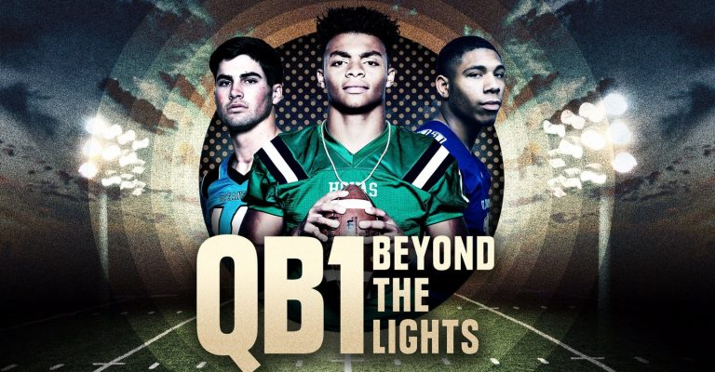

**QB1: Beyond the Lights** is an American sports documentary web series first broadcasted in 2017 and it was a big hit then in February 2018, season 2 was streamed and then in August 2019 season 3 was brought to the viewers screen.

**QB1** is a football documentary, which is grounded on the journey of three high school quarterbacks. It depicts a real story of the schema of high school football in USA explained through the views of the America’s top quarterbacks.

The **QB1 series** follows three teen athletes each season, each devoted to NCAA Division I Football programs as they mark their beginning as the senior in the high school who’s highly prompted to trace their NFL dreams. It’s a Netflix original television series, directed by Peter Berg with an immense budget in which the intense tussle of the quarterbacks is beautifully displayed. The last three seasons were able to successfully make a place for themselves in the heart of their viewers, those were great hits, and since then everyone is promptly waiting for the release of **qb1 season 4**.

**QB1 season 4 *release******date*:**

As we noticed that every new season of the **QB1: Beyond the Lights** is released amidst February to August every year. Like season 1 was released in February 2017, season 2 in February 2018, and then season 3 in August 2019. So, every one of us were expecting **qb1 season 4** to be released by August 2020. But because of the pandemic, shooting of the series was on the halt and so the release is pushed further to 2021 that too is merely an expectation nothing official has yet been released by the makers of the series but we hope so that it’ll be released by mid 2021.

**QB1 season 4 *Cast***:

While Netflix has not made any official announcement of the crew members who’ll be playing the role or who’ll be returning. There are so many new faces in every season so we’re again expecting new characters with new faces but nothing is predictable because there’s no information from the makers of the show. Like in season 1, we watched Tate Martell playing for Ohio State and Miami, Jake Fromm for Georgia, and Tayvon Bowers for Wake Forest. In season 2, we saw justin Fields for Georgia and Ohio State, Sam Hartman playing for Wake Forest, and then Mitchell for Lowa State. In season 3, Spencer rattler was seen playing for Oklahoma, Nik Scalzo for Kentucky, and Lance LeGendre was for Maryland. As of now we don’t have information about who’ll be the three quarterbacks but we’re expecting **Bryce Young** from California to be one of the quarterbacks as he’s a famous personality with an immense fan following on the social media. Additionally, there was tweet from Eric sondheimer too, which was directing Bryce Young to be one of the quartebacks. But yet there’s no official news yet. So, hold on your horses and let’s wait to see what’s there in **qb1 season 4** for us. 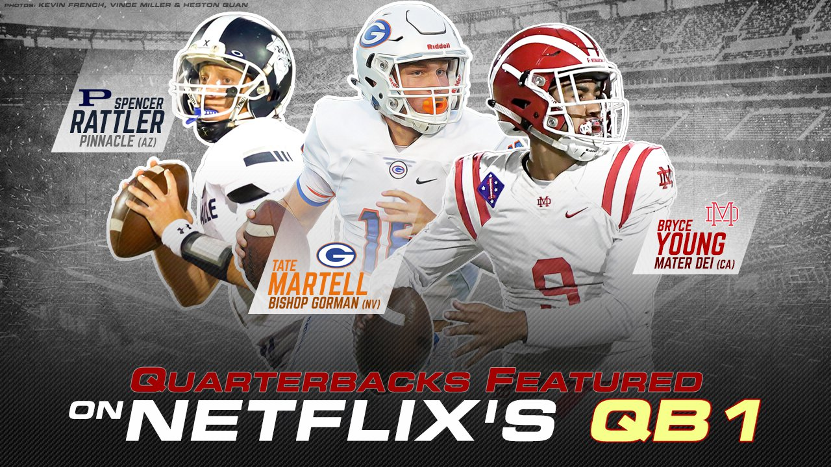

**QB1 season 4 *Plot*:**

In every **qb1 season** we watch the struggle and hard work stories of athletes. Every season introduces us to a new batch of athletes who struggle through athletic brilliance. The series show the difficulties and troubles these athletes face to be superior or have a respected position in sports. Other than these players, we get to know about the families of these athletes and feel the family pressure, these sports people have to cope up with. We also get to know and watch the high school dramas scenes and teenage issues these athlete youngsters face in their daily life. So, we’re again anticipating the same motif with different young teens and another new high school somewhere located in the US. So, get ready for experiencing quirky football culture of USA.

Till that time enjoy trailer of **qb1 season 3** 😊

https://www.netflix.com/in/title/81003033